Application Activity: Managing Finances
Name: Leida Josefina Pereira Hidrogo

Part 1: Self-Reliance
- Give at least two reasons why the self-reliant approach to finances can lead to greater peace and stability for you. Use at least one specific example from the course reading or your own life to support each reason in your response.
- Reason 1: Placing God first by paying tithing leads us to have a foundation for the future, in addition to obtaining greater peace and stability.
- Example from the course or your life to support this reason:
This principle is not just about money; it is a test of priorities, as President Dallin H. Oaks said. By doing this, we are establishing a solid foundation for our future, just as mentioned in the text. The self-reliance approach tells us: We receive money. We pay the Lord first. Peace and stability come from a promise. The manual quoted Heber J. Grant, who said that God gives us the wisdom so that with the remaining nine-tenths, we can accomplish more than we could with one hundred percent without His help. It is faith put into action. When I adhere to that principle, I feel greater peace of mind because I know I am aligning my finances with the priorities of the Gospel, and that, for me, means I am protected and receiving help to be wiser with the rest of my resources.

- Reason 2: Interest (charged on debt) can damage finances because it significantly increases the total cost of goods and services purchased on credit, diverting funds from future goals.
- Example from the course or your life to support this reason:
For me, the second fundamental reason why the self-reliance approach is crucial is because it forces you to face the real impact of interest. Interest, when it comes to debt (like credit cards or loans), is enormous damage to my finances. Interest significantly increases the total cost of anything I buy on credit. This means that the money I worked so hard to earn is not used to build my future, but is directly diverted to pay that extra cost called interest. That is why I avoid taking on debt that exceeds my capacity. In essence, interest makes me pay a much higher price for the creditor's patience. By increasing the total cost of goods, it takes away my ability to protect myself (as in the scripture Joseph preparing for the famine) and to invest in my education or retirement. That is why I am advised to be relentless in eliminating debt and paying more than the minimum: to minimize that damage and recover control of my resources for the future.

- Give one reason why interest can hurt your finances. Use at least one specific example from the course reading or your own life to support your response.
- Reason: Interest on debt drains personal financial resources, preventing the achievement of self-reliance. By prolonging payments, one ends up paying a much larger amount than the original cost of the item. This results in a significant portion of income working to enrich the creditor instead of being used for savings or the construction of one's own emergency fund.
Example from the course or your life to support this reason:
For me, this principle is essential because debt is such a huge obstacle to self-reliance. The order is: First the Lord, then the future, and finally, the present. Interest on debt simply subverts that entire plan. When I read that interest 'drains my financial resources,' I see it clearly: that extra money I am paying is not mine, it doesn't go to my emergency fund (my 'storehouse of grain,' like in the scripture of Joseph), and it's not investing in my education or retirement. By prolonging credit card or car loan payments, I am artificially increasing the cost of living.
The strongest part of this principle is that the result is that 'a significant portion of my income works to enrich the creditor instead of being used for me.' Instead of my effort bringing me closer to my goals, it is funding a third party. That is why the self-reliance approach urges us to be relentless with debt elimination. I understand that if I want to have peace and stability—the ultimate goal—I must ensure that my money works for me and my family, not for a bank. It is a matter of taking control, as the lesson teaches, and stopping being 'in captivity' to my circumstances.

Part 2: Open and Download Needed Files for the Budget
- Open your Expense Tracker Excel file. You were instructed to track all expenses and income for two weeks.
  - If you had access to a bank, you didn’t need to track expenses on the Expense Tracker file. It is now time to obtain a bank report of your recent account activity.
- Download the Budget Template Excel file. You will not turn in your actual budget but use it to honestly answer the questions at the end of this document.
  - If you do not have an income and you spend no money, you should still complete Parts 3, 4, and 5 of this assignment. Imagine an income and expenses. Use this as an opportunity to practice using a budget.

Part 3: Enter Income Sources and Budget Categories
- On the budget template, enter the start and end dates for your budget. This is typically the first of the month to the last day of the month or payday to payday. The budget needs to span one month.
- In column A, starting in row 10, list all your income sources for the coming month.
- Then in column B, give your best estimate of the amount of money you expect to earn from each source.
- Consider the list of expense categories in column D, and the categories you used in your Expense Tracker. Modify the categories to best fit your situation.
- Once you have listed your expense categories in column D, use column E to indicate whether each is a fixed or a variable expense. Your responses may differ from those in the example.
- Now, look at the expenses you tracked for the last two weeks to help you create a budget for the coming month. Even though you have only tracked for two weeks, you can multiply some of these items by 2 to fill a month. Enter the amount you plan to spend in each category in the appropriate cells in column F.

Part 4. Balance Your Budget
- Review that the total income you expect to earn is given in cell B8 and the total expenses in cell F8. If the number in cell F8 is more than the number in B8, it means that your planned expenses exceed your total income. Your budget is not balanced.
- Though there is likely not much you can do to adjust your fixed expenses, look over your variable expenses and make necessary adjustments until your Total Income expected (cell B8) is equal to or only slightly greater than the Total Expenses budgeted (cell F8).
  - If you can’t balance your budget by adjusting the variable expenses, you will need to consider what fixed expenses you can adjust (i.e. – reducing or canceling services, subscriptions, etc.) or what other income you could acquire.
- When you finish, your budget should look something like the following.
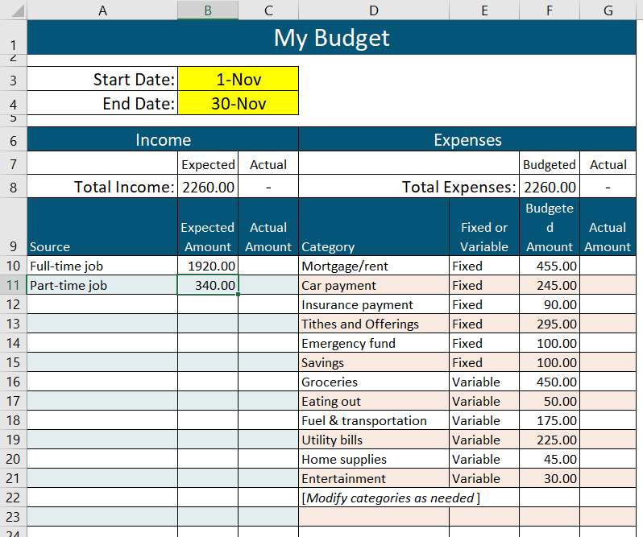

- Notice this assignment did not ask you to put in any information into columns C and G. Those columns are for you to fill in later. The course will not ask about this, but if you stick to this budget, the actual amounts should generally be equal to or less than the budgeted or expected amounts. It is up to you to manage your finances!

Part 5: Reflect
Answer the following questions.*

- Did you download and complete a budget?
__X_Yes
___No

- Did you classify each of your expenses as fixed or variable?
__X_Yes
___No

- Did you adjust the budget so your expenses did not exceed your income?
_X__Yes
___I didn’t need to
___No

- Describe at least one challenge to keeping a budget where your expenses do not exceed your income.
A challenge in maintaining a balanced budget is the difficulty of changing deep-seated spending habits and disciplining oneself to spend less money, especially if one currently spends a little more than one earns.

- Describe at least one way to overcome this challenge.
One way to overcome the challenge is to balance the budget through two basic actions: (1) spending less money (which requires discipline and habit change) and/or (2) earning more income (for example, by seeking education and professional advancement, as indicated in the lesson).

Submission Instructions
Just submit this document to the course for grading and feedback. You do not need to submit the budget that you completed.

*For questions 15-17, if you already have a budget that tracks expenses as fixed or variable, you may use that for reporting responses.

